**Probabilistic Neural Network**

**Assignment**

**Machine Learning**

Name : Muhammad Husain Toding Bunga | ID : 1301153626 | Class: IF-39-INT | Lecturer SYM

**Problem Description**

In this program assignment, we have been given 150 data training with its label and 30 data test. Each data have 3 attributes. The assignment is to build a program using Probabilistic Neural Network Algorithm to classify the data test as accurate as possible.

**Designed Method**

I solve this problem by using Probabilistic Neural Network first way, loading the data from data training file. After loading the data, I split the data, first 100 data will be the training data and the rest 50 data will act as validation to check whether the model is good or not. The main problem is finding the 𝜎.

I find 𝜎 by first generating random for the first iteration, in this case I use 1 as the 𝜎. And brute force the other number.

And then I use the pdf formula, these pdf formula will act as the perceptron in the Neural Network, and the validation/test data as the input. Summing all the perceptron/pdf results for each class will give us f(x) for each class. We select the maximum f(x) out of all 3 classes and that will be the data’s class.

**Results**

The results given by this program is the class of a data. Here are the training data visualization:

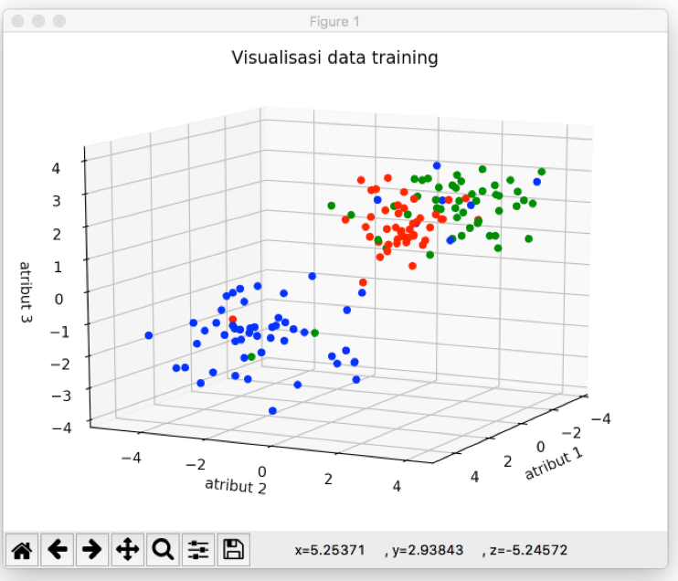

And here are the results:

­­­

|  |  |
| --- | --- |
| 1 | 2 |
| 2 | 0 |
| 3 | 0 |
| 4 | 0 |
| 5 | 0 |
| 6 | 0 |
| 7 | 0 |
| 8 | 1 |
| 9 | 0 |
| 10 | 0 |
| 11 | 1 |
| 12 | 0 |
| 13 | 0 |
| 14 | 1 |
| 15 | 1 |
| 16 | 2 |
| 17 | 1 |
| 18 | 1 |
| 19 | 0 |
| 20 | 0 |
| 21 | 0 |
| 22 | 2 |
| 23 | 2 |
| 24 | 0 |
| 25 | 0 |
| 26 | 2 |
| 27 | 0 |
| 28 | 2 |
| 29 | 2 |
| 30 | 0 |